Term Project: Identifying and improving telco customer churn

Leo Luera
University of Bellevue, MS Data Science
DSC 630 Predictive Analytics
March 8, 2026

Introduction
In subscription-based industries, customer churn poses a persistent challenge due to high competition, low switching costs, and growing value-added services. Predictive analytics provides an opportunity to anticipate churn behavior before it occurs, enabling organizations to take proactive steps to retain customers. Predicting human behavior is not a simple task, however this proposal outlines a predictive analytics project focused on customer churn using the IBM Telco Customer Churn dataset.
Canceling and switching subscriptions is a simple task these days, and customers can easily change services at any time. The objective of this project is to develop a predictive analytics model that identifies customers who are likely to churn from a telecommunications subscription service and support data-driven retention strategies. The resulting insights are intended to support decision making related to customer retention tactics, resource allocation, and service improvements.
Customer churn has a direct impact on revenue and long-term profitability in the subscription industry. Acquiring new customers is generally more costly than retaining existing ones. High churn rates can also signal underlying issues related to pricing, service quality, or overall customer satisfaction. Accurately predicting churn enables organizations to proactively improve customer satisfaction and allocate retention resources more efficiently.
Several stakeholders would benefit from solving this customer churn problem. Telecommunications companies can use churn predictions to design targeted retention campaigns. Marketing teams can tailor promotions and service improvements based on predicted risk. Product managers can identify features or services associated with dissatisfaction. Data scientists and analysts can improve forecasting capabilities, while executive leadership can use churn insights to guide strategic decisions related to growth and profitability.
The goal of this project is to identify the key factors that contribute to customer churn in a telecommunications setting and to improve understanding of how different modeling techniques influence predictive performance and interpretability. Additionally, this effort seeks to demonstrate how predictive analytics can be translated into actionable business recommendations that support customer retention efforts.
The initial expectation is that model performance will be useful, with ensemble models outperforming logistic regression in terms of ROC-AUC and recall for churners. I also expect contract type, tenure, and certain service features to emerge as key predictors. These expectations remain reasonable given the richness and structure of the IBM Telco Customer Churn dataset, though final performance will depend on issues such as class imbalance and feature quality.
There is potential for risks or ethical concerns in this work. Demographic variables may introduce bias if not handled carefully, potentially leading to unfair treatment of certain customer groups. There is also privacy concerns related to the use of customer data, even when anonymized. This project will acknowledge these concerns and emphasize responsible model use, transparency, and the role of human judgment in final decisions. In practice, I would recommend regular bias audits (e.g., comparing error rates across demographic groups) and limiting the use of sensitive attributes in decision rules, even if they improve raw model accuracy.
If challenges arise during the project, contingency options are available. Alternative churn datasets may be used if data quality issues arise. The modeling scope may be simplified to focus on a smaller set of high-impact variables. If predictive performance proves insufficient, the project may shift from individual churn prediction to churn risk segmentation, which can still provide valuable business insights. These steps ensure the project remains feasible and analytically meaningful.
Data Overview
The data used in this project comes from the IBM Telco Customer Churn dataset, a publicly available sample dataset commonly used for educational and analytical purposes. Per Kaggle, this sample data tracks a fictional telco company's customer churn based on a variety of possible factors. The Churn Label column indicates whether the customer left within the last month. Other columns include demographic information, dependents/partners, services used, payment information, and specific churn data.
The IBM Telco Customer Churn dataset is designed for predictive analytics due to its structured format and labeled churn outcome. The dataset includes demographic information, account details, service usage, billing data, and a labeled churn outcome. These variables are known drivers of churn behavior in subscription services and allow for supervised machine learning techniques to identify patterns associated with customer attrition.
Originally, my questions were broadly focused on why customers churn. For the third milestone, they were revised to:
- Which customer, contract, and service attributes are most strongly associated with churn in this dataset?
- How well can a classification model distinguish churners from non-churners, especially in terms of recall for churners?
- How might the model’s insights inform concrete retention strategies?
Methods of Analysis
Data cleaning began with encoding Churn Label target into binary for modeling. Next, identified columns that should be dropped: CustomerID, Count, Churn Label, Churn Score, CLTV, and Churn Reason. These columns were not necessary or helpful for modeling. Lastly, I ensured Total Charges was numeric and removed rows with missing values. Categorical variables were encoded using one-hot encoding to allow inclusion in the models.
The following bar charts, box plots, and correlation heatmap were created to better understand the data after cleaning. For reference, Churn Value = 1: the customer left the company this quarter. Churn Value = 0: the customer remained with the company.
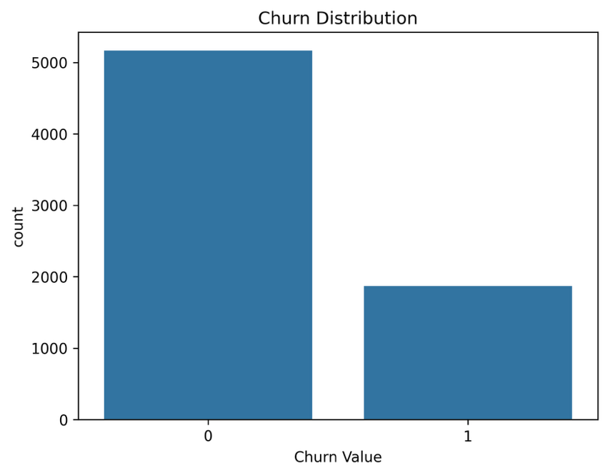

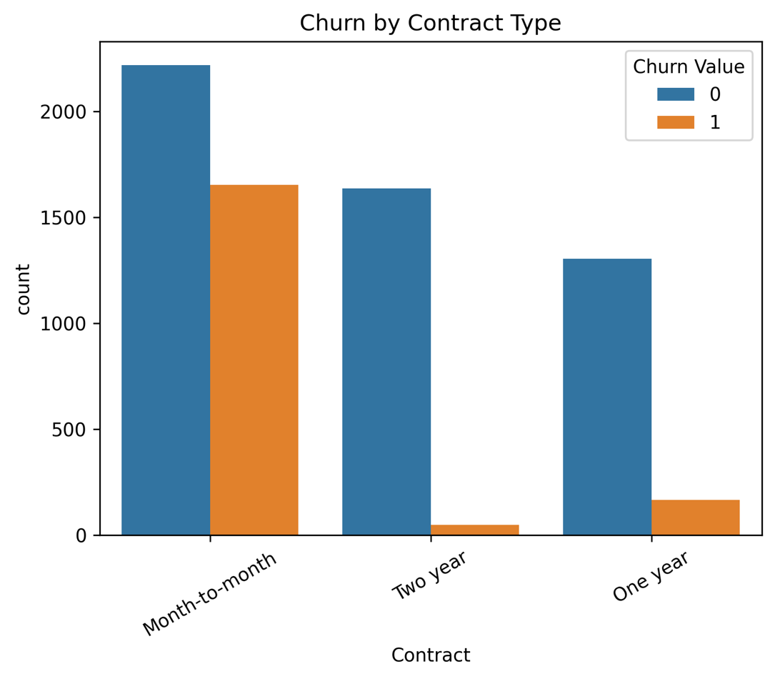
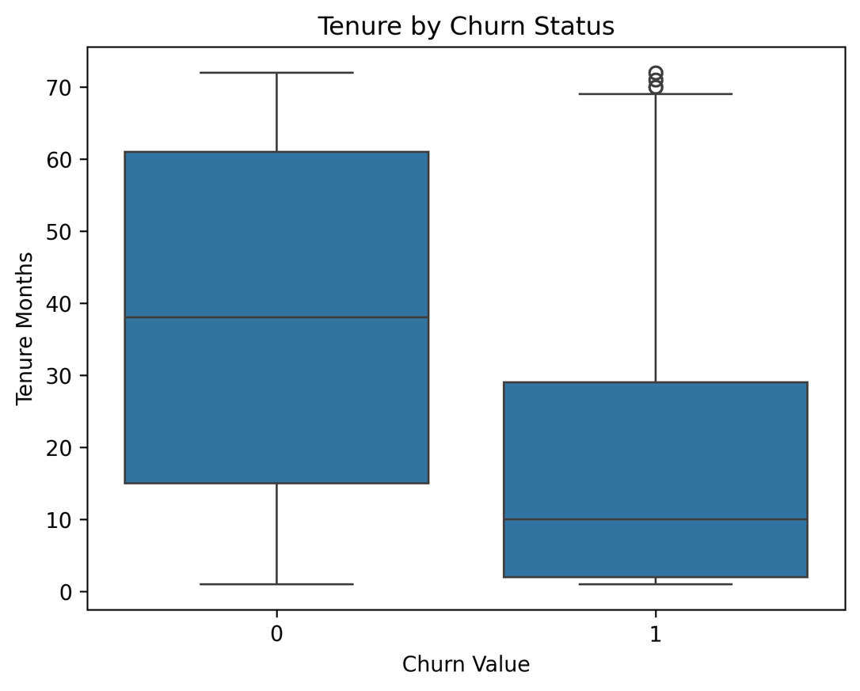

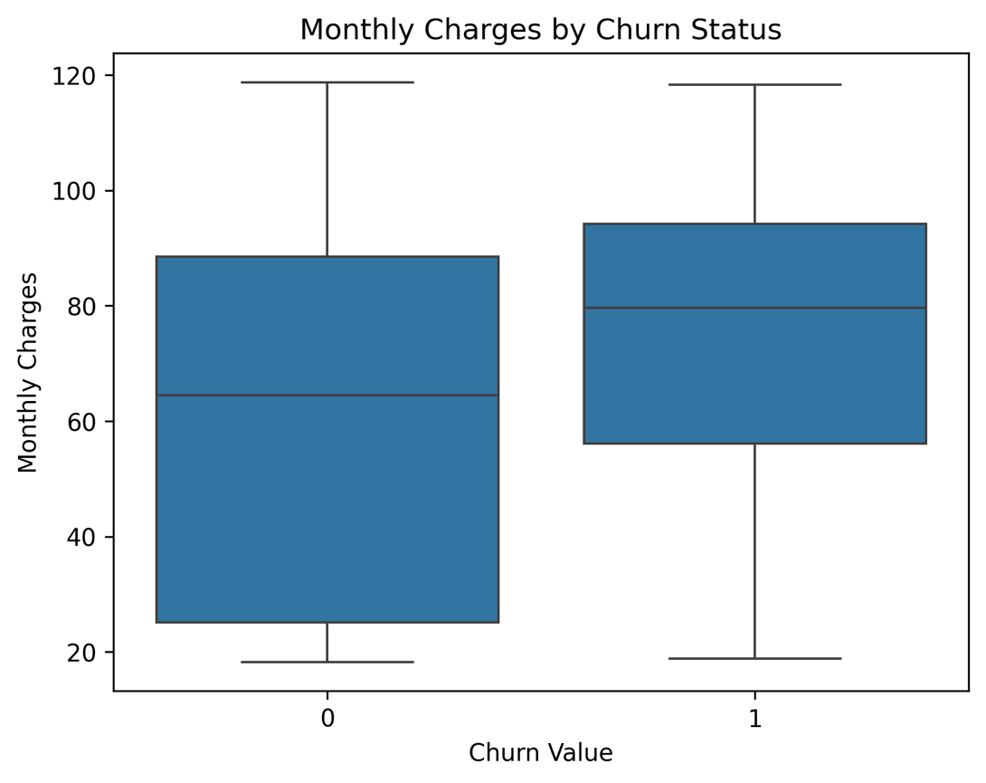
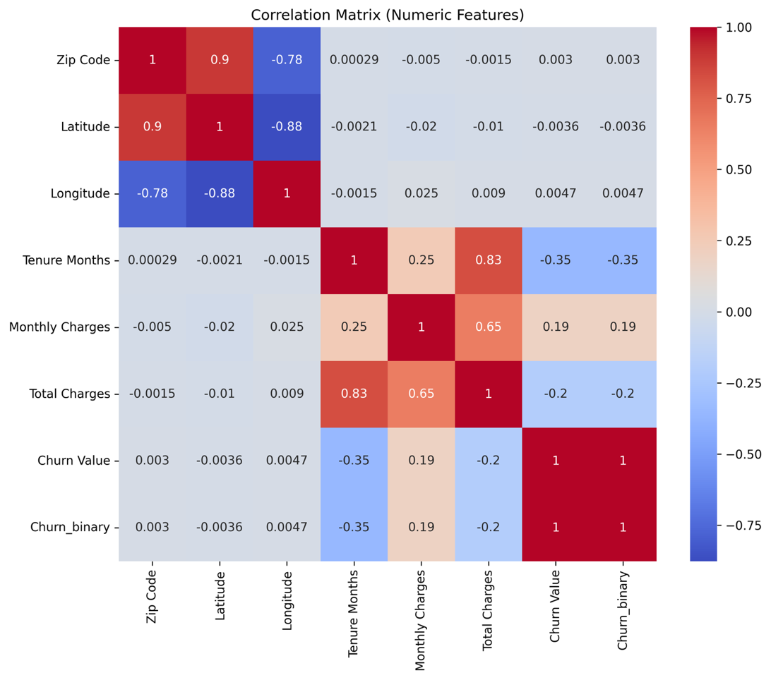
From the visualizations above, we get a clearer view at churners’ characteristics compared to non-churners. Churners represent about a quarter of the population of customers. We see strong churn concentration among month-to-month contracts and low-tenure customers, reinforcing the expectation that contract structure and customer longevity are primary churn drivers.
The roughly 25% - 27% of churners is not an extreme imbalance, but it could impact model behavior. This is why accuracy won’t be the metric primarily focused on in this work. Relying solely on accuracy would bias the model performance toward predicting retention.
The dataset was split into 80/20 training and testing sets. Feature scaling was applied using standardization for logistic regression models. Tree-based models (Decision Tree and Random Forest) were trained on unscaled data. Logistic regression was used as a baseline model due to its interpretability and effectiveness for binary classification problems. Decision tree and random forest models were explored to capture non-linear relationships between features and churn behavior.
Model performance will be evaluated using a combination of statistical and business-relevant metrics. Accuracy will serve as a baseline measure, while precision, recall, and F1-score will provide deeper insight into classification effectiveness. Exploration of the area under the receiver operating characteristic curve (ROC-AUC) will be used to review overall model discrimination.
Because the business objective is to prevent customer attrition, recall for the churners was prioritized. Recall for churners answers: “Of all customers who will churn, how many did we successfully identify?” From a business perspective, failing to identify a churner (false negative) results in lost revenue, whereas incorrectly flagging a non-churner (false positive) primarily results in additional marketing or retention outreach costs. Given that customer lifetime value typically exceeds outreach cost, minimizing false negatives is more important than minimizing false positives.
Results and Findings
In the first implementation, logistic regression and decision tree models were trained using default class weights and decision thresholds. Results indicate that the logistic regression model achieved relatively low recall for churners (0.41), whereas the decision tree substantially improved recall (0.82), demonstrating better sensitivity.

Log Regression Evaluation: Decision Tree Evaluation:
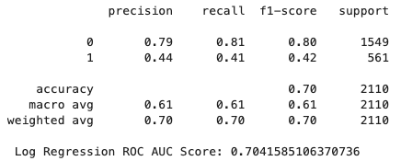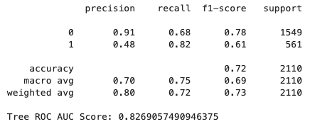
The next iteration of the Log Regression model included the addition of class_weight = "balanced".
Log Regression (Balanced) Evaluation:
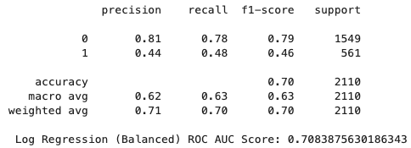
Applying class_weight modestly improved recall for churners (0.41 to 0.48), indicating that class imbalance contributed somewhat to model bias. However, the improvement was limited. As previously noted, the decision tree achieved substantially higher recall (0.82), implying that churn behavior in this dataset exhibits nonlinear structure and interaction effects.
Lastly, a Random Forest classifier was implemented to capture nonlinear relationships and reduce variance associated with single decision trees. Using multiple models allows for evaluation of trade-offs between interpretability and accuracy.

Random Forest Evaluation:
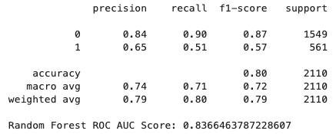
The RF achieved the highest ROC-AUC (0.84), indicating strong ability to distinguish churners from non-churners across probability thresholds. Recall was a moderate 0.51. The model’s high discrimination suggests that threshold adjustment could further improve churn detection while maintaining acceptable precision.
Conclusion
The proposal for this project originally outlined a comprehensive plan to address customer churn through predictive analytics using the IBM Telco Customer Churn dataset. By combining data exploration, machine learning models, evaluation, and ethical reflection, the project aimed to demonstrate how data-driven insights can support better decision making in telecommunications churn. In this project, we had three model outcomes:
- Logistic regression: interpretable, but limited nonlinear capture.
- Decision tree: high recall, but unstable and potentially overfit.
- Random forest: best overall discrimination and strongest deployment candidate.
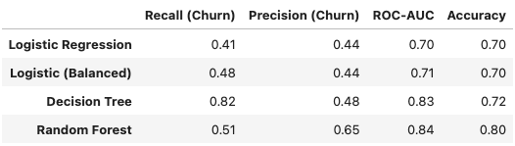
While logistic regression provides interpretability and stable performance (ROC-AUC ~ 0.71), tree-based methods better capture churn risk patterns and are more suitable when recall for churners is prioritized.
Logistic regression was expected to provide a strong, interpretable baseline, while ensemble methods, such as random forests, were likely to achieve higher predictive performance. The data clearly supported churn prediction, as logistic regression, decision tree, and random forest models achieve ROC-AUC > 0.70 and non-trivial recall for churners. The decision tree achieved higher recall for churners (0.82) compared to logistic regression (0.41), indicating that the dataset contains meaningful signal for identifying at-risk customers. The baseline logistic regression model struggled to identify churners (recall = 0.41), suggesting that linear decision boundaries may be insufficient. Tree-based models improved recall substantially, motivating further exploration of ensemble methods and threshold tuning.
If the average customer generates $1,200 annually and the retention effort costs $50, capturing even 10% of the 275 missed churners in the RF model could preserve approximately $33,000 in revenue. Therefore, there is a strong motivation to determine how to address the churn issue. Feature importance analysis suggests that month-to-month contracts, low tenure, and higher monthly charges are strongly associated with churn. Retention strategies should include:
- Target month-to-month customers within the first year of account creation.
- Prioritize retention campaigns for high monthly charge customers.
- Deploy the Random Forest model as it can be used as a risk-ranking system rather than a strict classifier.
- Adjust thresholds based on cost tolerance.
Because demographic variables are included in the dataset, the model may unintentionally encode structural biases. Fairness audits should evaluate whether false negative or false positive rates differ significantly across protected groups. Retention strategies informed by predictive models must balance fairness and efficiency, as preferential incentives for high-risk customers may unintentionally disadvantage consistently loyal customers. Customer data must be handled in compliance with privacy promises and regulations, ensuring transparency about how behavioral data informs retention decisions. Predictive outputs should inform human judgment, not replace it. Therefore, retention strategies should include human oversight to prevent automated decision systems from disproportionately affecting certain customer segments.

References
Abbott, D. (2014). Applied predictive analytics: Principles and techniques for the professional data analyst. John Wiley & Sons.
Chang, Y.-L. (n.d.). Telco customer churn (1113) [Data set]. Kaggle. https://www.kaggle.com/datasets/ylchang/telco-customer-churn-1113.
Siegel, E. (2016). Predictive analytics: The power to predict who will click, buy, lie, or die (Rev. & updated ed.). John Wiley & Sons.

